Quadrotor Drone

Core Product Requirements Document

CONFIDENTIALITY WARNING

This document contains information deemed confidential by Periscope Robotics. If you have not signed a confidentiality agreement, do not read further.

# Table of Contents

1 Table of Contents 2

2 Version History 4

3 Referenced Documents 5

4 Acronyms 6

5 Scope & Purpose 7

6 Market & Trade Studies 8

7 Product Overview 9

8 Requirements 10

8.1 Product Lifecycle 10

8.1.1 Expected Maintenance 10

8.1.2 Mechanical Maintenance Access 10

8.1.3 Software Maintenance Access 10

8.1.4 Expected Calibration 10

8.2 Product Performance 11

8.2.1 Endurance Time 11

8.2.2 Maximum Altitude 11

8.2.3 Maximum Climb 11

8.2.4 Payload Capacity 11

8.2.5 Battery Charging Speed 11

8.3 Core Features 12

8.3.1 Wireless Communication 12

8.3.2 Tethered Communication 12

8.3.3 Loss of Communication 12

8.3.4 Loss of Communication Behavior 12

8.3.5 Loss of Power Behavior 12

8.3.6 Rotor Movement Inhibit 13

8.3.7 Flight Parameters 13

8.3.8 Configurable Parameters 13

8.3.9 Battery Unsafe Detection 13

8.3.10 Weight on Wheels Detection 13

8.3.11 Battery Unsafe Behavior 14

8.4 User Interface 14

8.4.1 Battery Status Indication 14

8.4.2 Accessible Flight Parameters 14

8.4.3 Accessible Configurable Parameters 15

8.4.4 Loss of Power Indication 15

8.4.5 Host Application Flight Control 16

# Version History

|  |  |  |  |
| --- | --- | --- | --- |
| **Revision Name** | **Date Issued** | **Author** | **Change Summary** |
| Draft | -- | Jaden Bottemiller | -- |

# Referenced Documents

# Acronyms

|  |  |
| --- | --- |
| AMSL | Above Mean Sea Level |
|  |  |
|  |  |
|  |  |
|  |  |

# Scope & Purpose

This document is intended to give an overview of the Quadrotor drone project. It will outline the design intentions and methodology, as well as compare it to existing market solutions. Additionally, it will define requirements, from a broad perspective, primarily pertaining to marketability and ease of development.

This document is not intended to be a critical design document or contain requirements with specific implementation details.

# Market & Trade Studies

# Product Overview

The Quadrotor Drone consists of two primary features: the host application, where user input is handled and negotiated via the communication link to the actual “unit,” and the unit itself, which handles

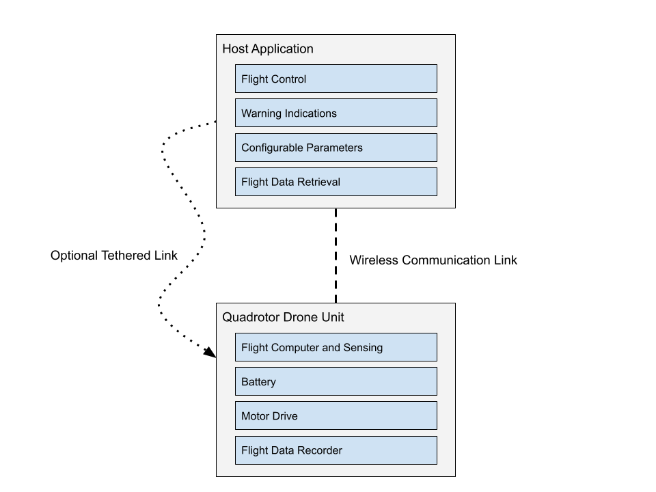

Figure 1- High Level Product Architecture

# Requirements

## Product Lifecycle

This section contains requirements related to the lifecycle of the product. For example: expected maintenance, frequency of maintenance, mean time between critical failures, etc.

### Expected Maintenance

Allocation: Unit

Safety Critical: Yes

Minimum Viable Product: Yes

The unit **shall** have an average time between maintenance activities of one thousand (1,000) flight hours.

Context: Expected maintenance does not include maintenance due to equipment mishandling by the end user.

### Mechanical Maintenance Access

Allocation: Mechanical

Safety Critical: No

Minimum Viable Product: No

In the event of any primary mechanical failure, the unit **shall** be separable and repairable by replacement of the primary mechanical feature.

Context: An example of a primary mechanical feature is a strut, or any other feature that when failed, could cause a catastrophic failure of the airframe. This requirement is based on best engineering judgement and marketability.

### Software Maintenance Access

Allocation: Software

Safety Critical: No

Minimum Viable Product: No

In the event of an update to flight software, the unit **shall** be field loadable.

Context: Flight software does not include the bootloader required to load the downloaded software into flash memory.

### Expected Calibration

Allocation: Hardware and Software

Safety Critical: No

Minimum Viable Product: No

The unit **shall** require a user-involved calibration routine a maximum of one (1) time in the product lifespan.

Context: This requirement does not include calibration required due to new software or hardware updates.

## Product Performance

This section contains requirements related to the performance of the product. For example, maximum altitude, endurance time, and payload capacity.

### Endurance Time

Allocation: Unit

Safety Critical: No

Minimum Viable Product: Yes

The unit **shall** be capable of flight for at least twenty (20) minutes immediately after the battery has been charged to its maximum safe capacity.

Context: This requirement is based on best engineering judgment, available battery technology, and marketability.

### Maximum Altitude

Allocation: Unit

Safety Critical: No

Minimum Viable Product: No

The unit **shall** be capable of flight for one (1) minute at a maximum altitude of five thousand (5,000) feet AMSL.

### Maximum Climb

Allocation: Unit

Safety Critical: No

Minimum Viable Product: Yes

The unit **shall** be capable of climbing to and maintaining an altitude three hundred (300) feet higher than the altitude of the lift-off point.

### Payload Capacity

Allocation: Unit

Safety Critical: No

Minimum Viable Product: No

The unit **shall** be capable of lifting an additional one hundred fifty (150) grams of payload without performance degradation.

### Battery Charging Speed

Allocation: Software and Hardware

Safety Critical: No

Minimum Viable Product: Yes

The unit **shall** be capable of charging its battery to its maximum safe capacity in one (1) hour or less.

Context: This requirement is based on best engineering judgement and available technology.

Allocation Justification: This requirement was allocated to hardware because hardware interfaces directly with the battery and the charge control circuitry.

## Core Features

This section contains features deemed to be vital to the core functions of the product. For example, means of communication, acceptable failure modes, etc.

### Wireless Communication

Allocation: Software and Hardware

Safety Critical: Yes

Minimum Viable Product: Yes

The unit **shall** be capable of communicating wirelessly to a host application up to at least five hundred (500) feet.

Context: This requirement is based on ideal conditions for wireless communication and best engineering judgement.

### Tethered Communication

Allocation: Software and Hardware

Safety Critical: Yes

Minimum Viable Product: Yes

The unit **shall** have a means of tethered communication on the ground.

### Loss of Communication

Allocation: Software and Hardware

Safety Critical: Yes

Minimum Viable Product: Yes

The unit **shall** be able to detect a loss of communication between the device and the host application.

### Loss of Communication Behavior

Allocation: Software and Hardware

Safety Critical: No

Minimum Viable Product: No

After a detected loss of communication, the unit **shall** begin a home base approach and landing until communication is regained and determined to be stable.

### Loss of Power Behavior

Allocation: Software and Hardware

Safety Critical: Yes

Minimum Viable Product: Yes

In the event of a critical loss of power, the unit **shall** execute a landing at its current position.

### Rotor Movement Inhibit

Allocation: Software and Hardware

Safety Critical: Yes

Minimum Viable Product: Yes

The unit **shall** inhibit high energy movement of the rotors while the device is tethered to the host application.

### Flight Parameters

Allocation: Software and Hardware

Safety Critical: No

Minimum Viable Product: No

The unit **shall** be able to record one (1) flight’s worth of flight parameters in non-volatile memory.

### Configurable Parameters

Allocation: Software and Hardware

Safety Critical: No

Minimum Viable Product: No

The unit **shall** be able to record, at a minimum, the following configurable parameters in non-volatile memory:

* home-base GPS coordinate
* communication parameters
* battery characteristic parameters

Context: Configurable parameters are required for homing, communication, and more. An example of a communication parameter would be a wireless network name and password. This list is based on best engineering judgement.

### Battery Unsafe Detection

Allocation: Software and Hardware

Safety Critical: Yes

Minimum Viable Product: Yes

The unit **shall** have a mechanism to detect the following unsafe battery conditions:

* Over voltage
* Under voltage
* Over discharge
* Out of range temperature

### Weight on Wheels Detection

Allocation: Software and Hardware

Safety Critical: Yes

Minimum Viable Product: Yes

The unit **shall** have a mechanism to detect whether the aircraft is in the air or on the ground.

Context: This property is sometimes referred to as “weight on wheels,” or W.O.W.

### Battery Unsafe Behavior

Allocation: Software and Hardware

Safety Critical: Yes

Minimum Viable Product: Yes

If an unsafe battery condition is detected as defined in Battery Unsafe Detection, the unit **shall** limit discharge to levels considered safe. Safe levels of discharge depend on the weight on wheels state defined in Weight on Wheels Detection.

Context: If the aircraft is in air, then the battery must discharge enough to make a safe landing. If the aircraft is on ground, high current discharge to the motors may be completely limited.

## User Interface

### Battery Status Indication

Allocation: Software and Hardware

Safety Critical: No

Minimum Viable Product: Yes

The unit **shall** have a mechanism to, without any external device, plainly display to the user, at a minimum:

* the state of the charge circuit
* the remaining capacity of the battery
* whether the battery is being limited due to unsafe conditions detected in Battery Unsafe Detection

Context: An example of a feature that would satisfy the requirement is a series of ten (10) LEDs where they indicate fully charged when they are all on, ninety (90) percent charged when nine (9) of them are on, and so forth. Requiring the unit to be plugged into a personal computer would not satisfy the requirement.

### Accessible Flight Parameters

Allocation: Software and Hardware

Safety Critical: No

Minimum Viable Product: No

The unit **shall** have a mechanism to retrieve (read) recorded flight parameters without major disassembly.

### Accessible Configurable Parameters

Allocation: Software and Hardware

Safety Critical: No

Minimum Viable Product: No

The unit **shall** have a mechanism to retrieve and change configurable parameters without major disassembly.

### Loss of Power Indication

Allocation: Software and Hardware

Safety Critical: Yes

Minimum Viable Product: Yes

The host application **shall** indicate a warning to the user if the unit is near the point of no return.

Context: The point of no return is defined as the point at which given the remaining capacity of the battery can no longer achieve a return to land at the home-base point or point of lift off.

### Host Application Flight Control

The host application **shall** 